Mobile Application Development Lab-Lab MSE

1. | Write an app to toast your joining date and course selected for engineering using date picker and list view.
2. | Write an app to demonstrate the activity lifecycle by logging the activities in the LogCat or toast at every stage ..
3. | Create an application which generates a random color on each click. .....................................................................
4. | Implement an app for flash screen using threads. ...................................................................................................
5. | Implement an app to store and retrieve data by using shared preference. ..............................................................
6. | Implement option menu concept in application to choose between two activities. .................................................
7. | Implement context menu concept in application to change the background color. .................................................
8. | Write an app to send SMS using Intent class. ..........................................................................................................
9. |  | Implement phone call concept in application by passing number from the user. ..................................................
10. |  | Demonstrate the sending of an email with the help of a registered email client on your android phone. .............

11. Insert the data entered by a user in to database and display all the values in database.

12. Search for a given USN from a student database and call to that student.

Part A

1. Write an app to toast your joining date and course selected for engineering using date picker and list view.

course_item.xml

<TextView xmlns:android="http://schemas.android.com/apk/res/android"

android:id="@+id/label"
android:layout_width="fill_parent"

android:layout_height="fill_parent"

android:padding="10dip"
android:textSize="16dip"

android:textStyle="bold" >

</TextView>

activity_main.xml

<?xml version="1.0" encoding="utf-8"?>
<LinearLayout

xmlns:android="http://schemas.android.com/apk/res/android"

xmlns:app="http://schemas.android.com/apk/res-auto"
xmlns:tools="http://schemas.android.com/tools"

android:layout_width="match_parent"

android:layout_height="match_parent"
tools:context="com.example.ananthu.finalsee.Q1"

android:orientation="vertical"

android:gravity="center">

<TextView
android:layout_width="wrap_content"

android:layout_height="wrap_content"

android:text="Select Joining Date!"
android:textSize="25dp"/>

<DatePicker
android:id="@+id/datePicker"

android:layout_width="wrap_content"

android:layout_height="wrap_content"

android:datePickerMode="spinner"
android:calendarViewShown="false"/>

<TextView
android:layout_width="wrap_content"

android:layout_height="wrap_content"

android:text="Select Course!"
android:textSize="25dp"/>

<ListView
android:id="@+id/courseList"

android:layout_width="wrap_content"

android:layout_height="wrap_content">

</ListView>

</LinearLayout>

package com.example.ananthu.finalsee;

import …

public class Q1 extends AppCompatActivity {

String[] mobileArray = {

"Biotechnology",

"Civil Engineering",

"Computer Science and Engineering",
"Electronics & Communications Engineering",

"Electrical & Electronics Engineering",

"Information Science and Engineering",
"Mechanical Engineering"

};
ArrayAdapter adapter;
DatePicker date;

@Override
protected void onCreate(Bundle savedInstanceState) {

super.onCreate(savedInstanceState);

setContentView(R.layout.activity_q1);

adapter = new ArrayAdapter<String>(this,

R.layout.course_item, mobileArray);

date = (DatePicker) findViewById(R.id.datePicker);

ListView listView = (ListView) findViewById(R.id.courseList);
listView.setAdapter(adapter);

listView.setOnItemClickListener(new AdapterView.OnItemClickListener() { @Override

public void onItemClick(AdapterView<?> parent, View view, int position, long id) {

String course = (String)adapter.getItem(position);

String dateString = date.getDayOfMonth() + "/" + ( 1 + date.getMonth() ) + "/" + date.getYear();

String toastString = "Joined on : " + dateString + "\ncourse : " + course;

Toast.makeText(getApplicationContext(), toastString, Toast.LENGTH_SHORT).show();
}
});

}
}
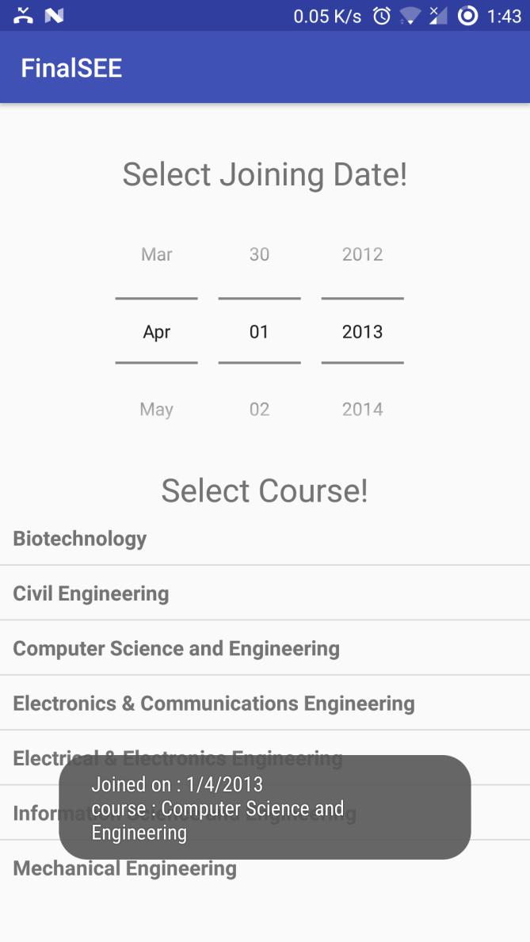

2. Write an app to demonstrate the activity lifecycle by logging the activities in the LogCat or toast at every stage

public class LifeCycle extends AppCompatActivity {

@Override
protected void onCreate(Bundle savedInstanceState) {
super.onCreate(savedInstanceState);

setContentView(R.layout.activity_life_cycle);

}

@Override
protected void onStart() {
super.onStart();

Log.i("life cycle", "start");

}

@Override
protected void onStop() {

super.onStop();
Log.i("life cycle", "stop");

}

@Override
protected void onDestroy() {

super.onDestroy();
Log.i("life cycle", "destroy");

}

@Override
protected void onPause() {

super.onPause();
Log.i("life cycle", "pause");

}

@Override
protected void onResume() {

super.onResume();
Log.i("life cycle", "resume");
}

}

3. Create an application which generates a random color on each click.

@Override
protected void onCreate(Bundle savedInstanceState) {

super.onCreate(savedInstanceState);

setContentView(R.layout.activity_life_cycle);

Button color = (Button) findViewById(R.id.color);

color.setOnClickListener(new View.OnClickListener() {

@Override
public void onClick(View v) {

RelativeLayout rl = (RelativeLayout) findViewById(R.id.layout);

Random gen = new Random();

rl.setBackgroundColor(Color.rgb(

gen.nextInt(256),

gen.nextInt(256),
gen.nextInt(256)

));

}
});

}

4. Implement an app for flash screen using threads.

public class Splash extends AppCompatActivity {

@Override
protected void onCreate(Bundle savedInstanceState) {
super.onCreate(savedInstanceState);

setContentView(R.layout.activity_splash);

new Thread(){

@Override
public void run()

{
try {
Thread.sleep(3000);
}catch (InterruptedException ex)

{
Log.e("error", ex.getMessage());

}
finally
{
startActivity(new Intent(getApplicationContext(), MainActivity.class));

}

}

}.start();
}

}

5. Implement an app to store and retrieve data by using shared preference.

public class sharedPref extends AppCompatActivity {

String prefName = "pName";

String prefTag = "pTag";

SharedPreferences pref;

SharedPreferences.Editor editor;

EditText text;

@Override
protected void onCreate(Bundle savedInstanceState) {
super.onCreate(savedInstanceState);

setContentView(R.layout.activity_shared_pref);

text = (EditText) findViewById(R.id.editText);

pref = getSharedPreferences(prefName, Context.MODE_PRIVATE);
text.setText(pref.getString(prefTag, ""));

}

protected void onPause(){

super.onPause();

editor = pref.edit();
editor.putString(prefTag, text.getText().toString()).commit();

}

}
6. Implement option menu concept in application to choose between two activities.

Activity_menu.xml (in menu resource folder)

<?xml version="1.0" encoding="utf-8"?>

<menu xmlns:android="http://schemas.android.com/apk/res/android">

<item android:id="@+id/f1"

android:title="First Activity"/>

<item android:id="@+id/f2"

android:title="Second Activity"/>

</menu>

MainActivity.java

public boolean onCreateOptionsMenu(Menu menu) {

MenuInflater inflater = getMenuInflater();
inflater.inflate(R.menu.activity_menu, menu);

return true;
}

public boolean onOptionsItemSelected(MenuItem item) {

- Handle item selection

switch (item.getItemId()) { case R.id.f1:

startActivity(new Intent(this,Main2Activity.class);); return true;

case R.id.f2:

startActivity(new Intent(this,Main3Activity.class);); return true;

default:
return super.onOptionsItemSelected(item);

}

}

7.Implement context menu concept in application to change the background color.

Activity_menu.xml (in menu resource folder)

<?xml version="1.0" encoding="utf-8"?>

<menu xmlns:android="http://schemas.android.com/apk/res/android">

<item android:id="@+id/red"

android:title="Red"/>

<item android:id="@+id/green"

android:title="Green"/>

<item android:id="@+id/blue"

android:title="Blue" />

</menu>

MainActivity.java

public boolean onCreateOptionsMenu(Menu menu) {

MenuInflater inflater = getMenuInflater();
inflater.inflate(R.menu.activity_menu, menu);

return true;

}

@Override
public boolean onOptionsItemSelected(MenuItem item) {

RelativeLayout rl = (RelativeLayout) findViewById(R.id.layout); switch (item.getItemId()) {
case R.id.red:
rl.setBackgroundColor(Color.RED);

return true;
case R.id.green:

rl.setBackgroundColor(Color.GREEN);

return true;
case R.id.blue:

rl.setBackgroundColor(Color.BLUE);

return true;

default:
return false;

}

}
8. Write an app to send SMS using Intent class.

public class SMS extends AppCompatActivity {

Button send;

EditText num, msg;
@Override
protected void onCreate(Bundle savedInstanceState) {
super.onCreate(savedInstanceState);
setContentView(R.layout.activity_sms);

send = (Button) findViewById(R.id.send);

num = (EditText) findViewById(R.id.number);
msg = (EditText) findViewById(R.id.message);

send.setOnClickListener(new View.OnClickListener() {
@Override
public void onClick(View v) {
String phoneNumber = num.getText().toString();
String message = msg.getText().toString();

Intent intent = new Intent(Intent.ACTION_VIEW, Uri.parse("sms:" + phoneNumber)); intent.putExtra("sms_body", message);

startActivity(intent);

}
});

}

}

9. Implement phone call concept in application by passing number from the user.

public class Call extends AppCompatActivity {

Button call;
EditText num;

@Override
protected void onCreate(Bundle savedInstanceState) {
super.onCreate(savedInstanceState);

setContentView(R.layout.activity_call);

ActivityCompat.requestPermissions(Call.this, new String[]{Manifest.permission.CALL_PHONE}, 1);

call = (Button) findViewById(R.id.call);
num = (EditText) findViewById(R.id.number);

call.setOnClickListener(new View.OnClickListener() {
@Override
public void onClick(View v) {
String number = num.getText().toString();
Intent callIntent = new Intent(Intent.ACTION_CALL);

callIntent.setData(Uri.parse("tel:" + number));

try {
startActivity(callIntent);
} catch (Exception e){
Log.d("error", e.getMessage());

Toast.makeText(getApplicationContext(), "call permission denied", Toast.LENGTH_SHORT).show(); //add this in manifest

//<uses-permission android:name="android.permission.CALL_PHONE" />
}

}

});
}

}

10. Demonstrate the sending of an email with the help of a registered email client on your android phone.

public class Email extends AppCompatActivity {

EditText id, sub, message;
@Override
protected void onCreate(Bundle savedInstanceState) {

super.onCreate(savedInstanceState);
setContentView(R.layout.activity_email);

id = (EditText)findViewById(R.id.mail_id);

sub = (EditText)findViewById(R.id.subject);
message = (EditText)findViewById(R.id.message);

Button send = (Button) findViewById(R.id.send);
send.setOnClickListener(new View.OnClickListener() {

@Override
public void onClick(View v) {

Intent i = new Intent(Intent.ACTION_SENDTO);
i.setType("text/plain");

i.putExtra(Intent.EXTRA_SUBJECT, sub.getText().toString());
i.putExtra(Intent.EXTRA_TEXT, message.getText().toString());

i.setData(Uri.parse("mailto:" + id.getText().toString()));

startActivity(i);

}

});
}

}

11. Insert the data entered by a user in to database and display all the values in database.

1 Activity - MainActivity

1 other Java File – DBHelper.java

2 layouts – activity_main.xml, student_item.xml

Activity_main.xml

<?xml version="1.0" encoding="utf-8"?>
<LinearLayout

xmlns:android="http://schemas.android.com/apk/res/android"

xmlns:app="http://schemas.android.com/apk/res-auto"
xmlns:tools="http://schemas.android.com/tools"

android:layout_width="match_parent"

android:layout_height="match_parent"
tools:context="com.example.ananthu.studentdatabase.MainActivity"

android:orientation="vertical"

android:gravity="center">

<EditText

android:id="@+id/name_input"

android:layout_width="match_parent"
android:layout_height="wrap_content"

android:hint="Enter name"

/>

<EditText

android:id="@+id/usn_input"
android:layout_width="match_parent"

android:layout_height="wrap_content"

android:hint="Enter USN"
/>
<EditText

android:id="@+id/phone_input"
android:layout_width="match_parent"

android:layout_height="wrap_content"

android:hint="Enter Phone Number"
/>

<Button

android:id="@+id/insertButton"
android:layout_width="wrap_content"

android:layout_height="wrap_content"

android:text="Insert"/>

<Button

android:id="@+id/getValues"
android:layout_width="wrap_content"

android:layout_height="wrap_content"

android:text="Get Values in database"/>

<TextView

android:layout_width="wrap_content"
android:layout_height="wrap_content"

android:text="Values in The DataBase"

android:textSize="20dp"/>

<ListView android:id="@+id/studentList"

android:layout_width="match_parent"
android:layout_height="wrap_content">

</ListView>

</LinearLayout>

Student_list.xml

<TextView xmlns:android="http://schemas.android.com/apk/res/android"

android:id="@+id/label"

android:layout_width="fill_parent"

android:layout_height="fill_parent"
android:padding="10dip"

android:textSize="16dip"

android:textStyle="bold" >

</TextView>

DBhelper.java

package com.example.ananthu.studentdatabase;

import …
public class DBHelper extends SQLiteOpenHelper {

public static String DB_NAME = "studentDB";

public DBHelper(Context context) {

super(context, DB_NAME, null, 1);

}

@Override
public void onCreate(SQLiteDatabase db) {
db.execSQL("create table student ( name, usn primary key, phone )");

}

@Override

public void onUpgrade(SQLiteDatabase db, int oldVersion, int newVersion) { }
}

MainActivity.java

package com.example.ananthu.studentdatabase;

import …

public class MainActivity extends AppCompatActivity {

SQLiteDatabase db;

Button insert;

Button select;

EditText name, usn, phone;

List<String> studentList;

ArrayAdapter adapter;

@Override
protected void onCreate(Bundle savedInstanceState) {

super.onCreate(savedInstanceState);
setContentView(R.layout.activity_main);

db = new DBHelper(this).getWritableDatabase();

insert = (Button) findViewById(R.id.insertButton);

select = (Button) findViewById(R.id.getValues);

name = (EditText) findViewById(R.id.name_input);

usn = (EditText) findViewById(R.id.usn_input);
phone = (EditText) findViewById(R.id.phone_input);

insert.setOnClickListener(new View.OnClickListener() {
@Override
public void onClick(View v) {

String inpName, inpUSN, inpPhone;

inpName = name.getText().toString();

inpUSN = usn.getText().toString();
inpPhone = phone.getText().toString();

if(inpName.equals("") || inpUSN.equals("") || inpPhone.equals(""))

{
Toast.makeText(getApplicationContext(), "Enter all values", Toast.LENGTH_SHORT).show();
}
else
{
ContentValues values = new ContentValues();
values.put("name", inpName);
values.put("usn", inpUSN);

values.put("phone", inpPhone);

db.insert("student", null, values);

Toast.makeText(getApplicationContext(), "Inserted!", Toast.LENGTH_SHORT).show();

}
}

});

select.setOnClickListener(new View.OnClickListener() {
@Override
public void onClick(View v) {

studentList = new ArrayList<>();

Cursor cursor = db.rawQuery("select * from student", null);

if (cursor.getCount() <= 0)

{
studentList.add("No values were present");

}
else

{
for (int i = 0; i < cursor.getCount(); i++) {
cursor.moveToNext();

String stud = "";
stud += " Name : " + cursor.getString(0);

stud += "\n USN : " + cursor.getString(1);

stud += "\n Phone Number: " + cursor.getString(2);

studentList.add(stud);

}

}
cursor.close();

adapter = new ArrayAdapter<String>(
getApplicationContext(),
R.layout.student_item,
studentList
);

ListView listView = (ListView) findViewById(R.id.studentList); listView.setAdapter(adapter);

}

});
}

}
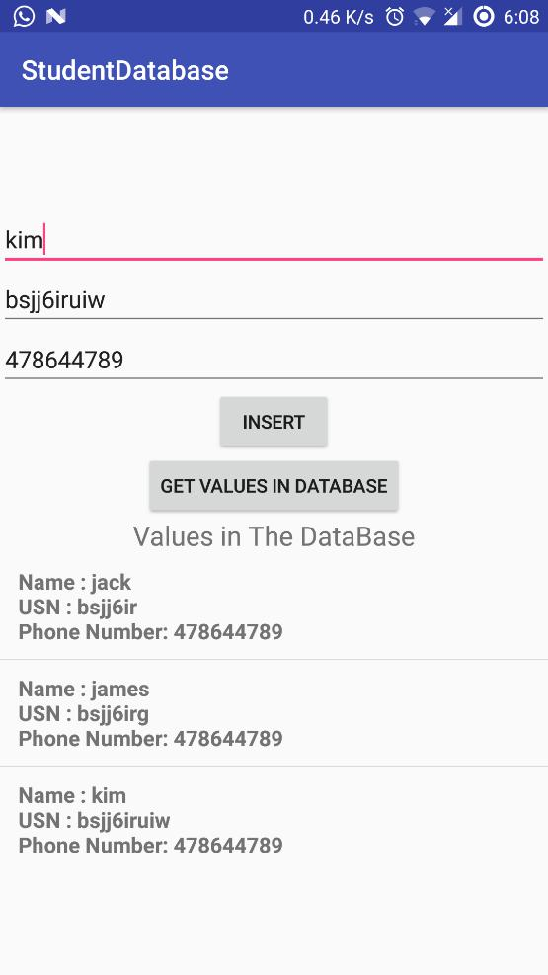

12.Search for a given USN from a student database and call to that student.

Same as before, add an input for usn and a button to call.

Change MainActivity to

package com.example.ananthu.studentdatabase;

import …

public class MainActivity extends AppCompatActivity {

SQLiteDatabase db;

Button insert, call;

EditText name, usn, phone , callUsn;

@Override
protected void onCreate(Bundle savedInstanceState) {
super.onCreate(savedInstanceState);

setContentView(R.layout.activity_main);

ActivityCompat.requestPermissions(this, new String[]{Manifest.permission.CALL_PHONE}, 1);

db = new DBHelper(this).getWritableDatabase();

insert = (Button) findViewById(R.id.insertButton);

call = (Button) findViewById(R.id.callButton);

name = (EditText) findViewById(R.id.name_input);

usn = (EditText) findViewById(R.id.usn_input);
phone = (EditText) findViewById(R.id.phone_input);

callUsn = (EditText) findViewById(R.id.call_usn_input);

insert.setOnClickListener(new View.OnClickListener() {

@Override
public void onClick(View v) {

String inpName, inpUSN, inpPhone;

inpName = name.getText().toString();

inpUSN = usn.getText().toString();
inpPhone = phone.getText().toString();

if(inpName.equals("") || inpUSN.equals("") || inpPhone.equals(""))
{
Toast.makeText(getApplicationContext(), "Enter all values", Toast.LENGTH_SHORT).show();

}
else

{
ContentValues values = new ContentValues();
values.put("name", inpName);

values.put("usn", inpUSN);

values.put("phone", inpPhone);

db.insert("student", null, values);

Toast.makeText(getApplicationContext(), "Inserted!", Toast.LENGTH_SHORT).show();
}
}

});

call.setOnClickListener(new View.OnClickListener() {

@Override
public void onClick(View v) {
String usn = callUsn.getText().toString();

if(usn.equals(""))
{
Toast.makeText(getApplicationContext(), "Enter an USN!", Toast.LENGTH_SHORT).show();

}
else

{

Cursor cursor = db.rawQuery("select * from student where usn = '" + usn + "'", null); //dont forget the single quotes
if(cursor.getCount() != 1)

{
Toast.makeText(

getApplicationContext(),
"Student not found!",
Toast.LENGTH_SHORT

).show();

}
else

{

cursor.moveToNext();

String phNumber = cursor.getString(2); //column 3 has phone number

Intent callIntent = new Intent(Intent.ACTION_CALL);

callIntent.setData(Uri.parse("tel:" + phNumber));
try {

startActivity(callIntent);

}
catch (Exception e){

Toast.makeText(getApplicationContext(), "call permission denied", Toast.LENGTH_SHORT).show(); //add this in manifest
//<uses-permission android:name="android.permission.CALL_PHONE" />
}

}
}
}

});
}

}
